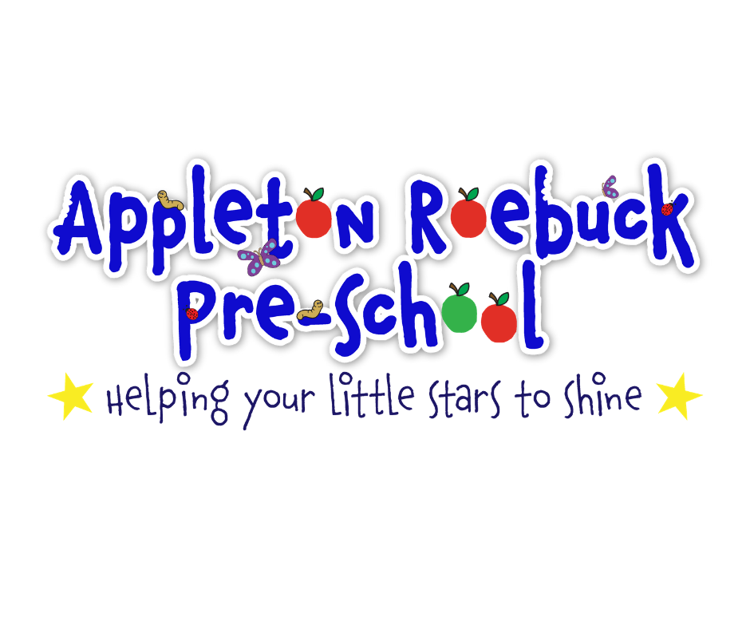

Application pack

September 2023

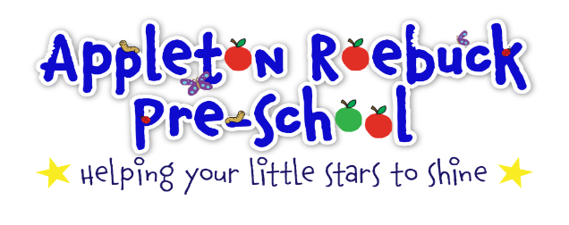

Dear Parent/Carer,

Thank you for your enquiry about Appleton Roebuck Pre-school.

Appleton Roebuck Pre-school is a registered charity. A committee of parents/carers is responsible for the employment of Pre-school staff, for maintaining Pre-school funds and to ensure Pre-school is properly managed.

Our staff are experienced and highly qualified:
Preschool Manager – Amy Woodcock
Deputy Manager – Marie Burke
Early years Practitioner Level 3 – Kelly Lindon
Early Years Assistant - Suzanne Cornforth
Early Years Assistant – Celia Swain

Child to staff ratios are kept as high as possible to ensure that your child gets all the care, attention, and encouragement he or she needs to achieve their full potential and shine.

At Pre-school, we put our children at the centre of everything we do. We believe that every child is unique and understand that children learn and develop at different rates. Through forming positive relationships and spending time in an enabling environment, children will learn and develop well. Our adults work both with you and your child, to understand them, know their interests and help to plan engaging and open, child-led learning. This, alongside our newly developed curriculum, will ensure that your child has the best possible start and equip them well as they transition into the next stage of their learning journey, primary school.

Our curriculum is based around the four seasons, looking at the changes that happen both in their village and around the world. It uses the seven areas of learning, set out in the Statutory Framework for Early Years as its foundation. The prime areas being Physical Development, Personal, Social and Emotional Development, Communication and Language. The specific areas are Understanding the World, Mathematics, Literacy and Expressive Arts and Design. Books play a huge part, and we focus on six specific texts each term and use them to enhance our learning. We are lucky to have a wide variety of resources to encourage your child to learn and develop their skills in these areas, including areas for messy activities, music time, story time, role-play, and a spacious outdoor area too.

Above all, we believe your child should have a fun-filled, rich, and engaging environment and the chance to make lots of friends.

To find out more about our Pre-school please see our website www.appletonroebuckpreschool.co.uk .
We also have a closed/secure Facebook group which we use to share information and encourage parents to use this group to communicate with other parents. Please join us at Facebook-Appleton Roebuck Preschool.

If you and your child would like to visit us at Pre-school, please contact the preschool manager and we will make the necessary arrangements.

Amy Woodcock – amy@appletonroebuckpreschool.co.uk

We look forward to welcoming you and your child to our Pre-school.

From the Staff and Committee, Appleton Roebuck Pre-School
Ofsted Registered number:538161
Early Years Registration Number:633245
Registered charity number number:1166924

Important Information

Opening times and costs from April 2020
An hourly rate of £4.50 will be charged for all sessions.
We operate during term time only. Opening times and available sessions are as follows:

Monday, Tuesday, Wednesday, Thursday, Friday, - 9.00am-3.00pm

9.00am-12.00pm - £13.50
9.00am-1.00pm - £18.00
9.00am-3.00pm - £27.00

Please find enclosed all the relevant documents required to apply to join us.

We hope you find this information pack helpful and informative. Documents included are:

- Application Form

- Registration Form

- Consent Form

- Settling your child

- Admissions Policy

- Data Protection – Fair Processing Notice

Next Steps
If you wish to apply, please complete and post all forms back to the preschool manager. You will be contacted to confirm we have received your application and arrange for your visit to Pre-school.

Please return to:
Amy Woodcock – amy@appletonroebuckpreschool.co.uk
Appleton Roebuck Preschool
Parish Rooms
Appleton Roebuck
YO23 7DJ
Telephone No. 07983 789482

Application to Join

Name of child:

Date of Birth: Male ☐ / Female ☐

Name(s) of parent(s) making the application:

Address(es):

Postcode:

Home/Mobile numbers:

Email address:

Please tick the day(s) you would like your child to attend

 | Full day 9-3pm | AM 9-12pm | AM with Lunch 9-1pm
Monday | ☐ | ☐ | ☐
Tuesday | ☐ | ☐ | ☐
Wednesday | ☐ | ☐ | ☐
Thursday | ☐ | ☐ | ☐
Friday | ☐ | ☐ | ☐

- My child is over 3 years old & I wish to claim for Early Years Education Funding☐
- I qualify for 2-Year-old funding and have a letter of eligibility☐
- I do not require funding please send me an invoice. ☐

When would you like your child to start at Pre-school?

Please tick your option to help your child settle at Pre-school.
☐ Visit to Playgroup (accompanied by an adult)
☐ Home visit
☐ I would just like my child to start

Signature: Date:

We try to accommodate your child on the days you have specified, and you will be contacted prior to your child taking up a place.
All Appleton Roebuck Preschool Policies and Procedures are available to read in paper format at Preschool. Our Safeguarding Policy is available on our website Appletonroebuckpreschool.co.uk

We would encourage all parents to have a look at our
Safeguarding Policy.

Please sign below to confirm you have seen the Safeguarding Policy.

Signed : Date:

REGISTRATION FORM

Full name of child: Date of Birth:

Male ☐ / Female ☐

Name Known as:

Name of parents/guardians with whom the child lives:

- Name:
Does this parent have parental responsibility? Yes ☐ / No ☐

Address of the parent:

Postcode:

Telephone: Mobile:

- Name:
Does this parent have parental responsibility? Yes ☐ / No ☐

Address of the parent:

Postcode:

Telephone: Mobile:

Name of parent/guardian with whom the child does not live (if applicable):

- Name:

Address of the parent:

Postcode:

Telephone: Mobile:

Does this parent have legal access to the child? Yes ☐ / No ☐

Emergency contact details

Parent 1 – Work ☐ / Mobile ☐ / Daytime ☐ Contact number:

Parent 2 – Work ☐ / Mobile ☐ / Daytime ☐ Contact number:

Any other emergency contact details

1 – Work ☐ / Mobile ☐ / Daytime ☐ Contact number:

Name: Relationship to child:

2 – Work ☐ / Mobile ☐ / Daytime ☐ Contact number:

Name: Relationship to child:

Persons authorised to collect the child (must be over 16 years of age)

1 – Work ☐ / Mobile ☐ / Daytime ☐ Contact number:

Name: Relationship to child:

2 – Work ☐ / Mobile ☐ / Daytime ☐ Contact number:

Name: Relationship to child:

Personal details of child

Does your child have any special dietary needs or preferences? Yes ☐ / No ☐ if yes please specify

Dietary information:

How would you describe your child’s ethnicity or cultural background?

What is the main religion in your family?

Are there any festivals or special occasions celebrated in your culture that your child will be taking part?
And that you would like to see acknowledged and celebrated while he/she is in our setting?

What language(s) is/are spoken at home?

If English is not the main language spoken at home, will this be your child’s first experience of being in an English-speaking environment? Yes ☐ / No ☐

If so discuss and agree with the key person how you will support your child when settling-in

Does your child have any special needs, disability or allergies? Yes ☐ / No ☐ if yes please specify

What special support will he/she require in our setting?

What other information is it important for us to know about your child? For example, what they like or what fears they may have, any special words they use, or what comforter they may need and when.

Name of professionals involved with child

Name 1: Role:

Agency: Telephone:

Name 2: Role:

Agency: Telephone:

Doctor

Name: Telephone:

Address:

Postcode:

Dentist

Name: Telephone:

Do you have a health visitor? Yes ☐ / No ☐

Name: Telephone:

Based at:

What is the reason for the involvement of social care department with your family?

NB If the child has a child protection plan, make a note here, but do not include details. Ensure these are obtained from social care worker named above and keep these securely in the child’s file.

APPLETON ROEBUCK PRE-SCHOOL CONSENT FORM
I am the parent/guardian of the named child and I give consent for
Name of Child:
(Please tick all that apply)
There may be occasions when pre-school wishes to take photographs of your child, we would like your permission to do this.
My child to be photographed for the following reasons:
☐ Learning Journey
☐ Wall displays
☐ Fundraising promotions
☐ Preschool website
☐ Appleton Roebuck Preschool to share information with other settings my child attends and provide school with information about my child prior to them starting school.
☐ Pre-school staff to apply sun cream, which I will provide.
☐ My child to have face paints applied at pre-school during parties/special activities.
☐ My child to be taken out into the village as part of the daily activities of the setting.
I understand that my further consent will be requested for major outings.

For emergency medical treatment:
☐ Pre-school staff to administer First Aid to my child if needed.
☐ Pre-school staff to take my child to A&E to be examined, treated and/or admitted on the understanding that I have been informed and I am on my way to hospital.

Parent/Guardian’s name:
Parent’s signature:
Date:

SETTLING YOUR CHILD AT PRE-SCHOOL

A child’s first day can be distressing for parent and child. It is a new situation for the child and often they become clingy and do not want to be left. It could be the first time they have spent time away from you. Naturally, how your child reacts depends on your child’s personality and temperament, however being prepared for the situation will make the transition smoother.

We have some top tips for helping you deal with the ‘settling-in’ process see below.

- Stay with your child at first. The amount of time you need to stay will depend on how well your child is settling in. Do not expect to take them on the first day and leave them straight away. This is a process and may take some time.

- Communicate clearly with your child when you are going to leave and ensure you actually go when you say you will. Do not prolong the leaving process - most children recover surprisingly quickly once their parent has left. Also, make sure you return to collect them when you say you will.

- Be very positive when talking about the setting in the child’s presence so they will establish a positive association with the setting.

- Be friendly and chatty towards the Pre-school staff so the child regards them as a friend and begins to trust them.

- Bring something comforting with you on your first visit to remind the child of home and make them a little more relaxed i.e., a blanket/teddy.

- Ensure you tell the staff as much as you can with regard to your child, so they are fully prepared.

- Try not to be too anxious yourself, as children will notice this.

ADMISSIONS POLICY

Admissions will be made in accordance with the current Local Education Authority criteria.

Priority group one
Children and young people in public care for whom the setting has been expressed as a preference and previously looked after children, that is children who were adopted (or subject to residence orders or special guardianship orders) immediately following having been looked after. Also, Children believed to have exceptional social or medical reasons for admission.

Priority group two
Children who have siblings within the setting.

Priority group three
Children living within the normal catchment area of the setting, giving priority to the oldest children first.

Priority group four
Children living outside the normal catchment area of the setting, giving priority to those whose home is nearest first.

Additional information

1. Registration
Parents/carers are required to register the child/ren and give information required on the registration form. This is a confidential form and only the relevant professionals, staff, parent or carer will have access to the registration forms and share your child’s information. We reserve the right to decline a registration if sufficient information is recorded that affects the smooth running of Pre-school. The Pre-school policies will be given on request. A child who is not registered cannot attend.
2. Bookings/attendance/changes
Booking into sessions on a casual basis is possible if we have spaces available; we do try to be as flexible as possible. If you require any additional sessions casually or permanently please speak to the Pre-school staff.
Parents/carers are requested to inform a staff member of non-attendance for holidays/sickness. Charges will be made for agreed bookings.
To change the regular booked days that your child attends or to terminate a place we may require 2 weeks’ notice.

3. Payment /Early Years Funding

Payment is due each half term. In certain circumstances (e.g. Families on income support), other arrangements can be made and the parent/carer should contact a member of committee to discuss options: treasurer@appletonroebuckpreschool.co.uk

Invoicing:
You will receive an invoice during the second week of each half term. Payments can be made through the following methods:
By BACS (preferable) – Bank account details required.
By childcare voucher- we currently offer the following childcare vouchers however, we can explore others if need be. Fideliti, Edenred, Childcareplus, Computershare and Care4.

Early years funding:
When your child is eligible for the funding the preschool manager will provide you with the appropriate forms for you to complete. All 3 and 4 year old’s are entitled to 15 hours funding or extended to 30 hours, if eligible per week to use at a maximum of 2 settings. 2 year old’s are entitled to 15 hours funding if the family meet the specified criteria. Please see the preschool manager if you are eligible for either funding.

4. Safeguarding
Children will only be released to parents/carers or an authorised person listed on the registration form. Please inform us in advance if your child is to be picked up by anyone other than yourself. We have a collection book to record this information, please ask a member of staff for this book.

5. Food & Drink
A healthy snack and drink are given at preschool. We promote healthy living and eating within our setting and our snack will usually consist of fruit and crackers/rice cakes. Each child is asked to bring a piece of fruit/vegetable each session, which is shared at snack time. We occasionally have treats brought in by children for special occasions, these will be given at snack time or given to take home. Children will have access to drinking water during session and either water or milk during snack time. If your child has any special dietary requirements, please make sure this information is recorded on the application form.

6. Medication
Parents/carers should give written permission by signing our medication book to enable our staff to administer any medication. All medication must be given to a member of staff on arrival, who will store it safely and at the required temperature. Children who require medication must have the necessary medication with them when attending. Long term/ongoing medication can be kept at preschool.

7. Sun Protection
Children should have sun lotion applied prior to attendance at pre-school. Staff members will only apply sun lotion which has been provided for each individual child and where consent has been given. Parents/carers should provide adequate clothing for outdoor activities e.g. sun hat. Children will play in the shade/inside at times of intense sunshine and be provided with drinks.

8. Trips
The preschool will inform parents/carers of any trips, provide them with information, and ask for signed agreement. Parents/carers will be asked to contribute towards trips (payment in advance) and volunteer support.
We do try to take children out into the village for walks; consent for this is to be given on application.

9. Personal Belongings.
Children are encouraged to bring in their own comforter if this will help settle them. We have a storage bucket where children are encouraged to place such items so that they do not get lost. Children are also encouraged to bring items of interest, which can be discussed at circle time. Staff will not be held responsible for loss of personal items and we will do our best to find any lost items, please do not bring items that will cause upset if lost/broken.

10. Book bags
When your child first starts at preschool you will be given a bookbag containing recent letters and forms you may need to complete and return. These bookbags should be brought to each session. They are to be returned to preschool when your child leaves. If you misplace your bookbag you will be asked to purchase a replacement.

11. Complaints
Parents/carers can speak to the pre-school manager or a committee member privately about any concerns. If the matter is not resolved, then a written complaint can be made to the Committee Chair. For further information, please see the Complaint’s Procedure document.

Privacy notice (GDPR 2018)

Appleton Roebuck Pre-School Privacy Notice

Appleton Roebuck Preschool
Parish Rooms
Daw Lane
Appleton Roebuck
YO23 7DJ

Introduction
We are committed to ensuring that any personal data we hold about you and your child is protected in accordance with data protection laws and is used in line with your expectations.

This privacy notice explains what personal data we collect, why we collect it, how we use it and how we protect it.

What personal data do we collect?
We collect personal data about you and your child to provide care and learning that is tailored to meet your child’s individual needs. We also collect information in order to verify your eligibility for free childcare as applicable.

Personal details that we collect about your child include:
- Your child’s name, date of birth, address, health and medical needs, development needs, and any special educational needs

Where applicable we will obtain child protection plans from social care and health care plans from health professionals.

We will also ask for information about who has parental responsibility for your child and any court orders pertaining to your child.

Personal details that we collect about you include:
- your name, home and work address, phone numbers, emergency contact details, and family details

This information will be collected from you directly in the registration form.

If you apply for up to 30 hours free childcare, we will also collect:
- Your national insurance number or unique taxpayer reference (UTR), if you’re self-employed. We may also collect information regarding benefits and family credits that you are in receipt of.

Why we collect this information and the legal basis for handling your data
We use personal data about you and your child in order to provide childcare services and fulfil the contractual arrangement you have entered into. This includes using your data to:
- contact you in case of an emergency
- to support your child’s wellbeing and development
- to manage any special educational, health or medical needs of your child whilst at [my/our] setting
- to carry out regular assessment of your child’s progress and to identify any areas of concern
- to maintain contact with you about your child’s progress and respond to any questions you may have
- to process your claim for up to 30 hours free childcare (only where applicable)
- to keep you updated with information about our service

With your consent, we will also record your child’s activities for their individual learning record. This may include photographs and videos. You will have the opportunity to withdraw your consent at any time, for images taken by confirming so in writing.

We have a legal obligation to process safeguarding related data about your child should we have concerns about their welfare. We also have a legal obligation to transfer records and certain information about your child to the school that your child will be attending (see sharing of Information Policy).

Who we share your data with
In order for us to deliver childcare services we will also share your data as required with the following categories of recipients:
- Ofsted – during an inspection or following a complaint about our service
- banking services to process chip and pin and/or direct debit payments (as applicable)
- the Local Authority (where you claim up to 30 hours free childcare as applicable)
- the government’s eligibility checker (as above)
- the school that your child will be attending

We will also share your data if:
- We are legally required to do so, for example, by law, by a court or the Charity Commission;
- to enforce or apply the terms and conditions of your contract with us;
- to protect your child and other children; for example by sharing information with social care or the police;
- it is necessary to protect our/or others rights, property or safety

We will never share your data with any other organisation to use for their own purposes

How do we protect your data?
We protect unauthorised access to your personal data and prevent it from being lost, accidentally destroyed, misused, or disclosed by:
Keeping your data in a locked environment or password protected laptop

How long do we retain your data?
We retain your child’s personal data for up to 3 years after your child no longer uses our setting, or until our next Ofsted inspection after your child leaves our setting. Medication records and accident records are kept for longer according to legal requirements. Your child’s learning and development records are maintained by us and handed to you when your child leaves.

In some instances (child protection, or other support service referrals) we are obliged to keep your data for longer if it is necessary to comply with legal requirements (see our safeguarding policy).
Automated decision-making
We do not make any decisions about your child based solely on automated decision-making.

Your rights with respect to your data
You have the right to:
- request access, amend or correct your/your child’s personal data
- request that we delete or stop processing your/your child’s personal data, for example where the data is no longer necessary for the purposes of processing; and
- request that we transfer your, and your child’s personal data to another person

If you wish to exercise any of these rights at any time or if you have any questions, comments or concerns about this privacy notice, or how we handle your data please contact us. If you continue to have concerns about the way your data is handled and remain dissatisfied after raising your concern with us, you have the right to complain to the Information Commissioner Office (ICO). The ICO can be contacted at Information Commissioner’s Office, Wycliffe House, Water Lane, Wilmslow, Cheshire, SK9 5AF or ico.org.uk/
Changes to this notice
We keep this notice under regular review. You will be notified of any changes where appropriate.
If you require more information about how the Local Authority (LA) and/or DfE store and use your information, then please go to the following websites:
http://www.northyorks.gov.uk/schoolrecords
http://www.education.gov.uk/researchandstatistics/datatdatam/b00212337/datause

If you are unable to access these websites, we can send you a copy of this information. Please contact North Yorkshire County Council or DfE as follows:

Data Management Officer
North Yorkshire County Council,
County Hall,
NORTHALLERTON, North Yorkshire,
DL7 8AD website:www.northyorks.gov.uk email:datamanagement.officer@northyorks.gov.uk

Public Communications Unit
Department for Education
Piccadilly Gate
Store Street
Manchester
M1 2WD
Website:www.education.gov.uk email:http://www.education.gov.uk/help/contactus
Telephone:0370 000 2288

