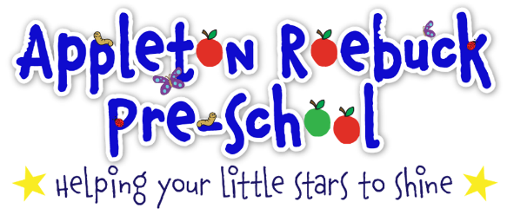
Preschool Weekly Newsletter

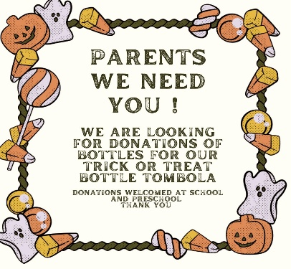
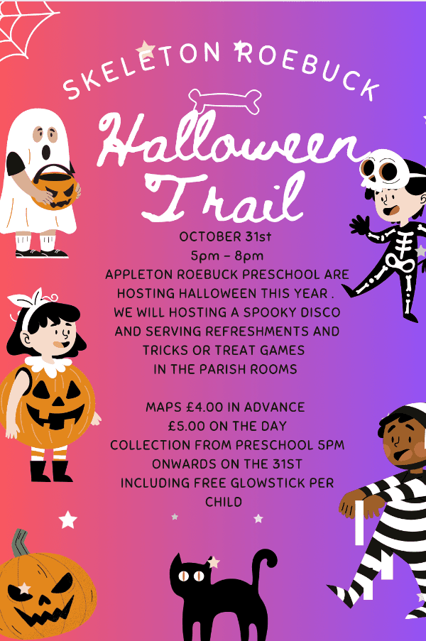
Ticket Link
https://www.ticketsource.co.uk/Appleton-Roebuck-Preschool-Group/t-rzlrzgn

For Halloween Event Tickets!
Next Week’s
Super Six
Book
will be…

This Week’s Super Six
Book has been…
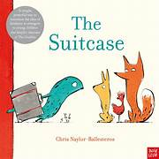
This week…
This is a bumper edition, catching everyone up on the last fortnight of preschool. It’s been a busy end to the Autumn term and the longest half term of the academic year. The children have very much enjoyed the story of the enormous turnip and we have spoken a lot about how we can work together to help each other to achieve our goals. We had a lovely harvest festival at the church and it was really nice to see so many parents and grandparents in attendance too. We’ve been busy over the last week, turning our attention to Halloween and making decorations for our big Halloween fundraiser. Next week, it’s our last week of the half term and we break up at 3pm on Thursday (23rd October) in line with the school training day on Friday. It will also sadly be Hannah’s last week with us as she embarks on her new position as a teaching assistant. Hannah will be greatly missed by us all but we wish her all the luck in her new role. Hannah’s last day will be Thursday.
Hello and welcome to our newsletter, bringing you all the latest news and information from Appleton Roebuck Preschool
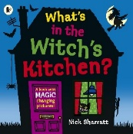

Infection Control

I’m very pleased to say that we seem to be over our recent bout of illnesses, here at preschool. We haven’t had a case of hand, foot and mouth reported for over a week!

When I spoke with the practitioner at Infection Control, they were impressed with the actions we had taken to limit the spread of germs and were really happy with all of the information we’ve shared with parents.

Thank you for all of your efforts in helping us to limit the spread of illness amongst the children.

Hopefully, we’ll get through the next half term unscathed!
Reminders
Remember to pack spares – it’s amazing how many changes of clothes we go through in preschool and particularly handy to have more spares as the weather turns wetter.
Do send uour child with a coat – we do get out in all weathers, its very good for us all!
If you know that someone other than the person at drop off, will be collecting your child then do let us know on the door and please remember to set up a password for your chosen person.
If your child is going to be absent from preschool for any reason, please do let us know as it helps us to fulfil our very important safeguarding roles.
THANK YOU!

Next week… We will be looking at Halloween with lots of related stories and activities.
Last day of Autumn Term 1 is Thursday 23rd October.
First day back is Monday 3rd November.
Don’t forget that you can send us photos of things you are doing at home on Class DOJO.

